Maths
White Rose Autumn Term | White Rose Spring Term | White Rose Summer Term

Cycle A
 | Autumn |  | Spring |  |  | Summer
Driver Project | Set in stone  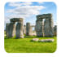 |  | Rocks, Relics and Rumbles   |  |  | Ruthless Romans  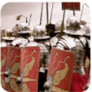
History | Set in stone |  | Tracks through Time |  |  | Ruthless Romans
Science | Electricity Y4 |  | Animals including humans Y3 and Y4 |  |  | Forces and Magnets Y3 | Forces Y5
Geography | Close to home |  | Rocks, relics and rumbles |  |  | The map beneath our feet
D&T | Cook Well, Eat well |  | Making it Move |  |  | Green house
Art | Colour Theory | Prehistoric Pots | Ammonite | People and places |  | Beautiful Botanicals |  | Mosaic Masters
RE | What is the best way for a Jew to lead a good life? Judaism | What is the most significant part of the Nativity story for Christians today? Christianity | How do Jewish beliefs, teachings and stories impact on daily life? Judaism |  | Is forgiveness always possible for Christians? Christianity | Do people need to go to church to show they are Christians? Christianity | How does celebrating Shavuot help Jewish children feel closer to God? Judaism
Computing | Online Safety  Touch Typing | Email | Online Safety  Route Planners |  | Spreadsheets | Online Safety  Coding | Presentation -Microsoft, Apple & Google
Music | Writing Down Music  Playing in a Band |  | Compose using your Imagination  More Musical Styles |  |  | Enjoying Improvisation  Opening Night
P.E | Cross Country  Basketball | Dance Wild Animals  Handball | Gymnastics- Canon and Unison  Symmetry and Asymmetry  Games Sense Invasion |  | Game Sense Net/Wall  Football | Tennis  Athletics  Orienteering  Y3/4 Swimming | Cricket  Tag Rugby
PSHE Y3 | Being Me in My World | Celebrating Difference | Dreams and Goals |  | Healthy ME | Relationships | Changing me
PSHE Y4 | Being Me in My World | Celebrating Difference | Dreams and Goals |  | Healthy ME | Relationships | Changing me
PSHE Y5 | Being Me in My World | Celebrating Difference | Dreams and Goals |  | Healthy ME | Relationships | Changing me

Maths
White Rose Autumn Term | White Rose Spring Term | White Rose Summer Term

Cycle B
 | Autumn |  | Spring |  |  | Summer
Driver Project | Raided, Invaded and Stayed!  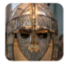 |  | Misty Mountains and Winding Rivers   |  |  | Tomb Raiders  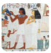
History | Raided, invaded, stayed! |  | Secrets of the streets |  |  | Tomb Raiders
Science | States of Matter Y4 |  | Human reproduction and aging |  | The circulatory system | Light Y3 | Sound Y4
Geography | Marvelous Maps |  | Misty Mountains and Winding Rivers |  |  | Energising our future
D&T | Healthy Food  Packaging |  | Functional and Fancy Fabrics |  |  | Tomb Builders
Art | Story telling through drawing |  | Exploring still life (Option 2) |  |  | Sculpture, structure, inventiveness and
RE | What might Sanatanis learn from the story of Rama and Sita in the celebrations of Diwali? Hinduism | Has Christmas lost its true meaning? Christianity | Could Jesus heal people? Did he perform miracles or was there some other explanation? Christianity | What is ‘Good’ about Good Friday? Christianity |  | Does visiting the Ganges make a person a better Sanatan? Hinduism |  | What is the best way for a Sanatani to lead a good life? Hinduism
Computing | Online Safety  Animation | Unpacking Hardware & Software | Online Safety  Sound Stories | Logo  Effective Searching |  | Online Safety  Coding | Composing Beats  Introduction to AI
Music | Musical Structures  Exploring Feelings When You Play |  | Compose with Your Friends  Feelings Through Music |  |  | Expression and Improvisation  The Show Must Go On!
P.E | Netball  Cross Country | Basketball  Tchoukball | Tag rugby  Gymnastics Bridges |  | Football  Dance-Space | Athletics  Tennis  Y3/4 Swimming | Cricket  Kin Ball
PSHE Y3 | Being Me in My World | Celebrating Difference | Dreams and Goals |  | Healthy ME | Relationships | Changing me
PSHE Y4 | Being Me in My World | Celebrating Difference | Dreams and Goals |  | Healthy ME | Relationships | Changing me
PSHE Y5 | Being Me in My World | Celebrating Difference | Dreams and Goals |  | Healthy ME | Relationships | Changing me

Maths
White Rose Autumn Term | White Rose Spring Term | White Rose Summer Term

 | Autumn |  | Spring |  |  | Summer
Driver Project | 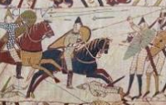 |  | 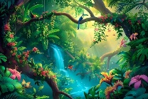 |  |  | 
History | Stormin Normans |  | Pyramids, Priests, and Prophecies |  |  | Groundbreaking Greeks
Science | Plants Y3 | Rocks Y3  Adapt planning | Properties and Changes of Materials Y5 |  |  | Living Things and their Habitats Y4  Living Things and their Habitats Y5 Adapt planning
Geography | Seeds, soil and sunshine |  | Journey to the Emerald Kingdom |  |  | A good place to settle
D&T | Moving Mechanisms |  | Eat the Seasons |  |  | Architecture
Art | Nature’s Art |  | Line, Light and Shadows |  |  | Mixed Media
RE | What is the best way for a Sanatani to show commitment to God? | IS the Christmas story true? | How can Brahman be everywhere and in everything? |  | How significant is it for Christians to believe that God intended Jesus to die? | Do beliefs in Karma Samsara and Moksha help Sanatanis lead good lives? | What is the best way for a Christian to show commitment to God?
P.E | Year 5  Cross Country  Dodge Ball | Year 5  Basketball  Gymnastics- Flight | Year 5  Hockey  Tag Rugby | Year 5  Netball  Orienteering |  | Year 5  Athletics  Tennis | Year 5  Cricket  Dance- Greeks
Computing | Online Safety  Quizzing | Databases | Games Creator  Concept Maps | Spreadsheets |  | Coding | Word Processing – Microsoft, Apple & Google
Music | Melody and Harmoney in Music  Sing and Play in Different Styles |  | Composing and Chords  Enjoying Musical Styles |  |  | Freedom to Improvise  Battle of the Bands!
PSHE Y3 | Being Me in My World | Celebrating Difference | Dreams and Goals | Healthy ME |  | Relationships | Changing me
PSHE Y4 | Being Me in My World | Celebrating Difference | Dreams and Goals | Healthy ME |  | Relationships | Changing me
PSHE Y5 | Being Me in My World | Celebrating Difference | Dreams and Goals | Healthy ME |  | Relationships | Changing me
Cycle C

Year 6 overview
Maths
White Rose Autumn Term | White Rose Spring Term | White Rose Summer Term
Year 6 overview –One year cycle
 |  | Autumn |  | Spring |  | Summer
 | Driver Project | Over the Top (WW1)  Blitz and Pieces (WW2)  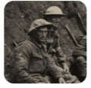 |  | Frozen Kingdoms   |  | Tremendous Tudors  Brilliant Benin  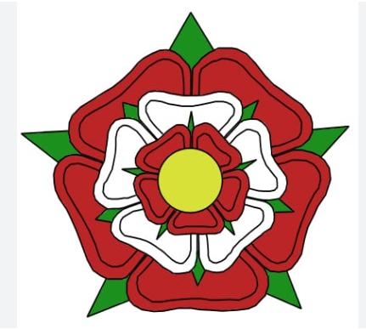
 | History | WW1 and WW2 |  | The Titanic |  | Benin and Tudors (a comparison)
 | Science | Light | Earth in Space | Evolution and inheritance and adaptation |  | Electrical circuits and components
 | Geography | European Expedition: Journey through the boot of Europe |  | Frozen Kingdom |  | Trading Places
 | D&T | Make do and mend |  | Engineer |  | Food for Life
 | Art | 2D drawing to 3D making (option 1) |  | Exploring identity |  | Brave Colour
 | RE | What is the best way for a Muslim to show commitment to God?  Islam | Do Christian celebrations and traditions help Christians understand who Jesus was and why he was born?  Christianity | Is anything ever eternal?  Christianity | How is the Qur’an vital to Muslims today?  Islam | Does belief in Akhirah (life after death) help Muslims lead a good life?  Islam | Is Christianity still a strong religion over 2000 years after Jesus was on Earth?  Christianity
 | Computing | Online Safety  3D models | Coding | Python | Spreadsheets | Graphing | Networks
 | Music  Charanga Year 6 | Developing melodic phrases |  | Gaining confidence through performance |  | School Production  And using chords and structure
 | P.E | Cross Country  Netball  Gymnastics | Basketball  Volleyball | Tag Rugby  Hockey | Dance  Tennis | Athletics  Orienteering | Rounders  Cricket  Swimming
 | PSHE | Being me in my world | Celebrating difference | Dreams and goals | Healthy me | Relationships | Changing me

