Overarching Vision
At Barns Green Primary School, we consider mathematics as far more than simply a core curriculum topic; it is central to helping children become happy, articulate, reflective and confident individuals. Developing numerical fluency prepares children to access a world surrounded by number and problem solving. It equips young people with key skills such as calculating, estimating, observing and predicting, which will be used extensively throughout their lives.
Our Values and Vision underpins the purpose of the teaching of Mathematics within our school.
OUR SCHOOL VALUES AND VISION
Our Values are:
- Respect
- Responsibility
- Perseverance
- Compassion
- Community
- Inclusion

Our Vision is:

Promoting independent thought and learning
Providing a broad-based education
Respecting individuality and difference
Emphasising the importance of team work
Nurturing physical health, emotional security and spiritual richness
Our pupils will learn to become self-confident, enthusiastic, resilient and tolerant.

There are certain key aims that demonstrate the intent for the teaching of mathematics in our school. We teach children that having a growth mindset will help them to persevere when they find tasks challenging and that we learn through trial and error. At Barns Green, we believe that our teaching of mathematics:

• promotes enjoyment of learning through practical activity, exploration and discussion;
• develops confidence and competence with numbers and the number system;
• develops the ability to solve problems through decision-making and reasoning in a range of contexts and
• helps children understand the importance of mathematics in everyday life.

All children are given opportunities to:
• develop a sense of the size of a number and where it fits into the number system (place value);
• become fluent in number facts such as number bonds, multiplication tables, doubles and halves;
• solve simple problems mentally, using jottings personal to them and the bar model to visualise the problem;
• calculate accurately and efficiently, both mentally and with pencil and paper, drawing on a range of calculation strategies and judging whether their answers are reasonable;
• explore the features of shape and space, and develop measuring skills in a range of contexts and
• explain and make predictions from the numbers in graphs, diagrams, charts and tables

Introduction
The maths mastery approach is embedded into the teaching and learning of mathematics in our school. We understand that this is a continuous journey of constantly improving our mathematical pedagogy. The rationale our approach to teaching mathematics lays within the NCETM Maths Hub Programme as well as the 2014 National Curriculum, which states:
• The expectation is that most pupils will move through the programmes of study at broadly the same pace.
• Pupils who grasp concepts rapidly should be challenged through being offered rich and sophisticated problems before any acceleration through new content.
• Those who are not sufficiently fluent with earlier material should consolidate their understanding, including through additional practice, before moving on.

FLUENCY – REASONING – PROBLEM SOLVING

These three key aims of the National Curriculum should be addressed in each sequence of learning.

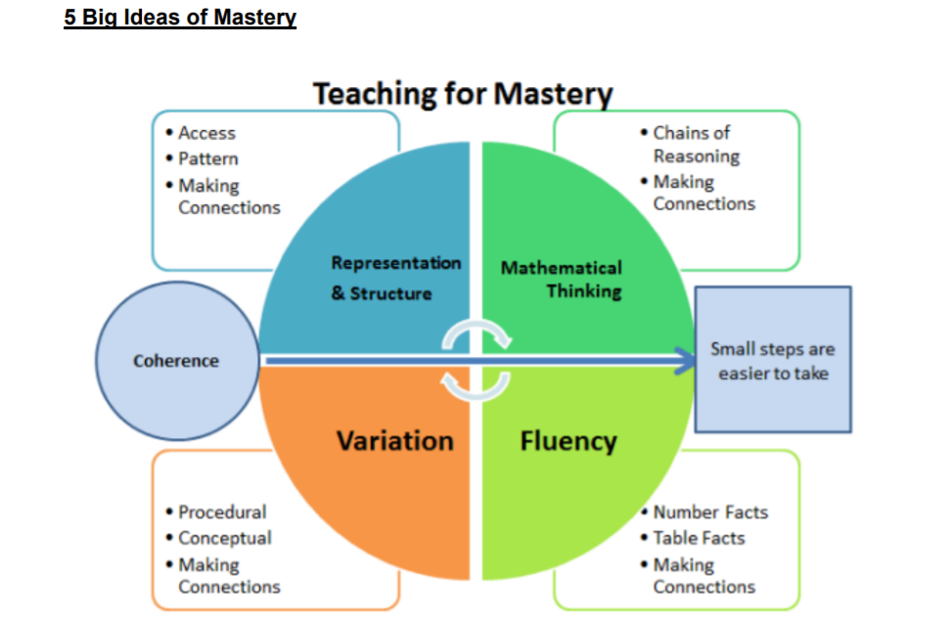

Our teaching and implementation for mastery is underpinned by the NCETM’s 5 Big Ideas. • Opportunities for Mathematical Thinking allow children to make chains of reasoning connected with the other areas of their mathematics.
• A focus on Representation and Structure ensures concepts are explored using concrete, pictorial and abstract representations, the children actively look for patterns and generalise whilst problem solving.
• Coherence is achieved through the planning of small, connected steps to link every question and lesson within a topic.
• Teachers use both procedural and conceptual Variation within their lessons and there remains an emphasis on Fluency with a relentless focus on number and times table facts.

8 Classroom Norms to Establish:
1. Everyone can learn mathematics to the highest levels.
2. If you ‘can’t do it’, you ‘can’t do it yet’ (Growth Mindset).
3. Mistakes are valuable.
4. Questions are important.
5. Mathematics is about creativity and problem solving.
6. Mathematics is about making connections and communicating what we think.
7. Depth is much more important than speed.
8. Mathematics lessons are about learning, not performing.

Teaching for Mastery Principles
• It is achievable for all – we have high expectations and encourage a positive ‘can do’ mind-set towards mathematics in all pupils, creating learning experiences which develop children’s resilience in the face of a challenge and carefully scaffolding learning so everyone can make progress.
• Deep and sustainable learning – lessons are designed with careful small steps, questions and tasks in place to ensure the learning is not superficial.
• The ability to build on something that has already been sufficiently mastered – pupils’ learning of concepts is seen as a continuum across the school.
• The ability to reason about a concept and make connections – pupils are encouraged to make connections and spot patterns between different concepts (E.g. the link between ratio, division and fractions) and use precise mathematical language, which frees up working memory and deepens conceptual understanding.
• Conceptual and procedural fluency – teachers move mathematics from one context to another (using objects, pictorial representations, equations and word problems). There are high expectations for pupils to learn times tables, key number facts (so they are automatic) and have a true sense of number. Pupils are also encouraged to think whether their method for tackling a given calculation or problem is Appropriate, Reliable and Efficient (A.R.E).
• Problem solving is central – this develops pupils’ understanding of why something works so that they truly have an appreciation of what they are doing rather than just learning to repeat routines without grasping what is happening.
• Challenge through greater depth - rather than accelerated content, (moving onto next year’s concepts) teachers set tasks to deepen knowledge and improve reasoning skills within the objectives of their year group.

Curriculum design and planning

• Staff use White Rose Maths Schemes of Learning as well as the NCETM materials as a starting point in order to develop a coherent and comprehensive conceptual pathway through the mathematics. The focus is on the whole class progressing together.
• Learning is broken down into small, connected steps, building from what pupils already know. The lesson journey should be detailed and evident on whiteboards (Lynx or PowerPoint) and within teacher’s plans.
• Difficult points and potential misconceptions are identified in advance and strategies to address them planned.
• Key questions are planned, to challenge thinking and develop learning for all pupils.
• Contexts and representations are carefully chosen to develop reasoning skills and to help pupils link concrete ideas to abstract mathematical concepts.
• The use of high-quality materials and tasks to support learning and provide access to the mathematics, is integrated into lessons. These may include White Rose Maths Schemes of Learning and Assessment Materials, NCETM Mastery Assessment materials, NRICH, visual images and concrete resources.
• Opportunities for extra fluency practice (instant recall of key facts, such as number bonds, times tables, division facts, addition and subtraction facts) should be provided outside mathematics lessons (morning starters, post lunch or lesson transitions).

Lesson Structure
• Lessons are sharply focused; digression is generally avoided.
• Key new learning points are identified explicitly.
• There is regular interchange between concrete/contextual ideas, pictorial representations and their abstract/symbolic representation.
• Mathematical generalisations are emphasised as they emerge from underlying mathematics, which is thoroughly explored within contexts that make sense to pupils.
• Making comparisons is an important feature of developing deep knowledge. The questions “What’s the same, what’s different?” are often used to draw attention to essential features of concepts.
• Repetition of key ideas (for example, in the form of whole class recitation, repeating to talk partners etc.) is used frequently. This helps to verbalise and embed mathematical ideas and provides pupils with a shared language to think about and communicate mathematics.
• Teacher-led discussion is interspersed with short tasks involving pupil to pupil discussion and completion of short activities.
• Formative assessment is carried out throughout the lesson; the teacher regularly checks pupils’ knowledge and understanding and adjusts the lesson accordingly.
• Gaps in pupils’ knowledge and understanding are identified early by in-class questioning. They are addressed rapidly through individual or small group intervention, either on the same day or the next day, which may be separate from the main mathematics lesson, to ensure all pupils are ready for the next lesson.
• Teachers discuss their mathematics teaching regularly with colleagues, sharing teaching ideas and classroom experiences in detail and working together to improve their practice.
• Mastering Number is used throughout the school to embed mathematical fluency.

Marking

Next steps can be provided narrow gaps between learners or to extend a child’s understanding. However, it is essential that all marking picks up and addresses any misconceptions/mistakes and thorough questioning ensures children have clarified their thinking clearly.

Assessment and Record Keeping

In addition to the formative assessment undertaken in lessons and summative end of topic assessments from White Rose, teachers will use termly summative assessments (during Assessment Week) supplied by the NFER to reinforce their judgements and provide further opportunities to identify gaps in pupil learning and tailor future lessons. Teacher judgements are then entered onto our traffic light grid each half term and teachers talk through the progress of their pupils at termly tracking progress meetings: this ensures targeted support can be given to those who need it.

Interventions
Interventions in maths should be based on developing key number skills that are appropriate for the children involved. Intervention provided to boost children’s progression in maths should be tightly planned, with success criteria set and assessments made frequently to ensure progress is being made. These interventions are either “catch up” or “keep up” interventions. Whilst interventions could be carried out by Teaching Assistants, for example, what is being taught and how it is delivered is the class teacher’s responsibility and communication is essential. When possible, teachers should be delivering the interventions. Interventions should be in sync with the child’s current learning in class.

Inclusion and Special Needs

Barns Green aims to meet the needs of all, taking into account gender, ethnicity, culture, religion, language, disability, age and social circumstances. The provision for children with special needs is detailed in the SEND Policy. SEND pupils may be supported by additional adults, different resources, differentiated activities. They may also complete additional activities outside of the mathematics lesson. We have high expectations of all children and strongly believe that all children are able to achieve in mathematics. Some may take longer to grasp concepts and may need careful scaffolding or extra time/support.

Resources
A bank of essential mathematics resources are kept in each classroom tray drawers and cupboards. Further resources are kept in the General resources cupboard for all to share, such as the large Numicon packs. Teacher’s reference and resource books are kept in the PPA room. There is also a published scheme available – Abacus children workbooks are kept in the relevant year group classrooms. However, teachers should use resources which best fits the success criteria – these might come from the published schemes but might come from elsewhere such as resources from the Internet, Numicon handbooks and other teacher guides.

Display
In the classrooms there will be mathematical vocabulary displayed so that children use this in the communication of their understanding. There will be maths work on display in classrooms and/or in other areas of the school in order to encourage a positive attitude and enthusiasm towards mathematics for all groups of children. All classrooms will display a selection of stem sentences.

Early Years Foundation Stage (EYFS)

Children in EYFS explore mathematical concepts through active exploration and their everyday play-based learning. Children are taught key concepts and develop number sense using a hands-on practical approach. EYFS practitioners provide opportunities for children to manipulate a variety of objects which supports their understanding of quantity and number. Pupils explore the ‘story’ of numbers to twenty and the development of models and images for numbers as a solid foundation for further progress. The CPA approach is used when teaching children key mathematical skills. Practitioners allow children time for exploration and the use of concrete objects helps to support children's mathematical understanding. Mathematics in the early years provides children with a solid foundation that will enable them to develop skills as they progress through their schooling and ensures children are ready for the National Curriculum.

Role of the Subject Leader
• Ensures teachers understand the requirements of the National Curriculum and supports them to plan lessons. Leads by example by setting high standards in their own teaching.
• Leads continuing professional development; facilitates joint professional development – especially Lesson Study; provides coaching and feedback for teachers to improve pupil learning.
• Leads the whole-school monitoring and evaluation of teaching and learning in mathematics by observing teaching and learning in mathematics regularly; analysing assessment data in order to plan whole school improvement in mathematics; conducting work scrutiny to inform evaluation of progress; conducting pupil interviews.
• Takes responsibility for managing own professional development by participating in external training, independent private study, engaging in educational research and scholarly reading and keeping up-to-date with Teaching for Mastery developments.
• Keeps parents informed about mathematics issues.
• Ensures that the school’s senior leaders and governors are kept informed about the quality of teaching and learning in mathematics.
• Works in close partnership with the school’s senior leaders to ensure the learning needs of all pupils in mathematics are met effectively.
• Keeps the school’s policy for mathematics under regular review.

